Project Report: Password Helper and Analyzer

General Overview
This project is designed to help users generate secure passwords and analyze their strength. It consists of multiple Java classes that work together to create strong passwords and assess their security level. The project aims to enhance password security by providing users with guidance on password strength and suggesting improvements where necessary. The primary objectives include:
• Generating random yet secure passwords.
• Evaluating password strength based on various security criteria.
• Providing feedback to users for improving password security.

Code Functionality
The project consists of three main Java classes: Main.java, PasswordHelper.java, and PasswordAnalyzer.java. Below is a detailed breakdown of their functionality:
1. Main.java
• This serves as the entry point of the program.
• It manages user interaction, allowing users to either generate a password or analyze an existing one.
• The program prompts users for input and then invokes the appropriate methods from PasswordHelper and PasswordAnalyzer.
• Based on the user’s choice, it either generates a new password or evaluates an entered password.
• The results are displayed to the user, providing necessary feedback on password strength.
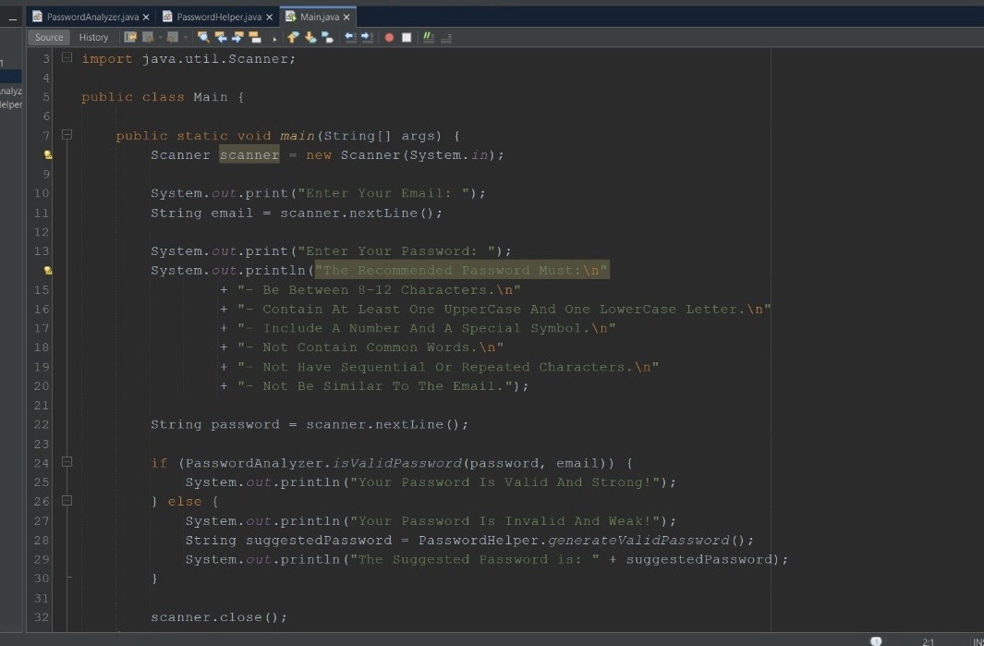
2. PasswordHelper.java
• This class is responsible for generating secure passwords based on defined security parameters.
• It creates passwords that include uppercase letters, lowercase letters, numbers, and special characters to enhance security.
• The method uses a randomization technique to ensure that each generated password is unique and difficult to guess.
• It may allow customization options such as password length and character inclusion preferences.
• Example logic in this class could involve using Java’s Random class or SecureRandom for enhanced security.

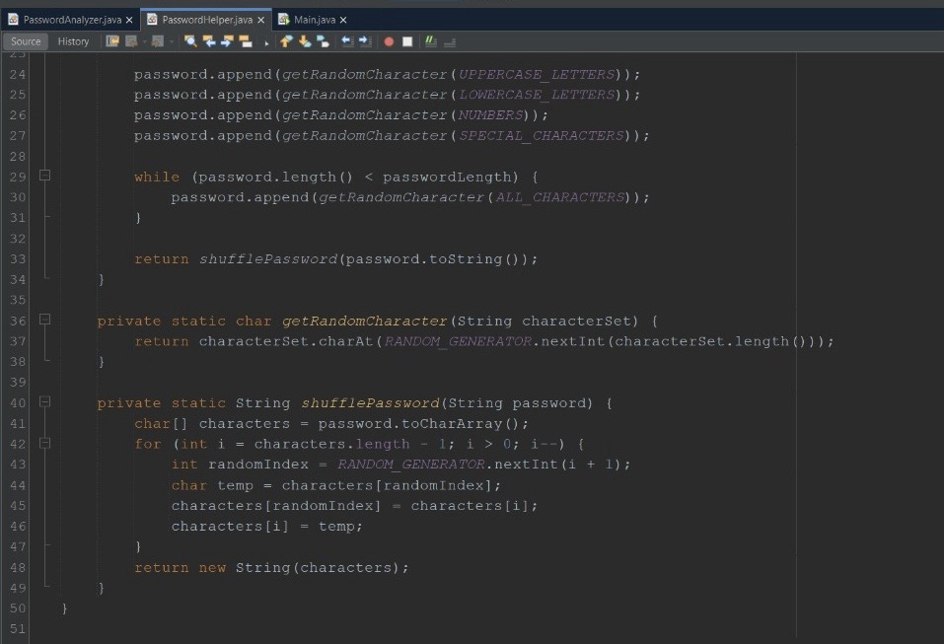
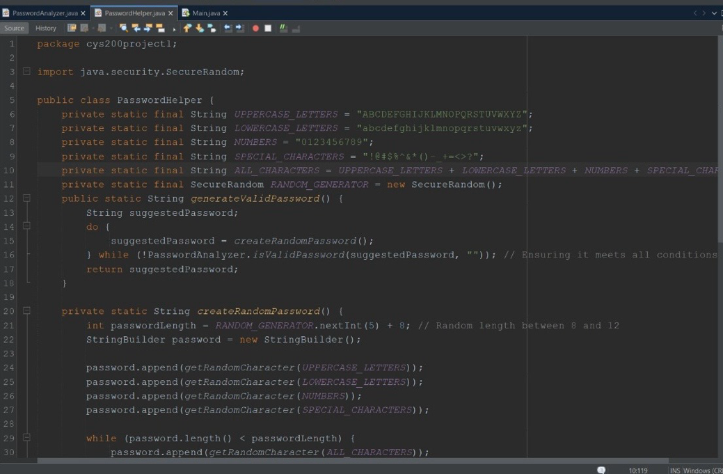

3. PasswordAnalyzer.java
• This class assesses the strength of a given password based on various security criteria.
• The analysis includes checking:
• The length of the password (longer passwords are generally more secure).
• The presence of uppercase and lowercase letters, numbers, and special characters.
• Whether the password contains common words or predictable patterns.
• The program then categorizes the password into different strength levels, such as:
• Weak: If it lacks diversity and is too short.
• Moderate: If it meets some criteria but could be stronger.
• Strong: If it meets all security recommendations.
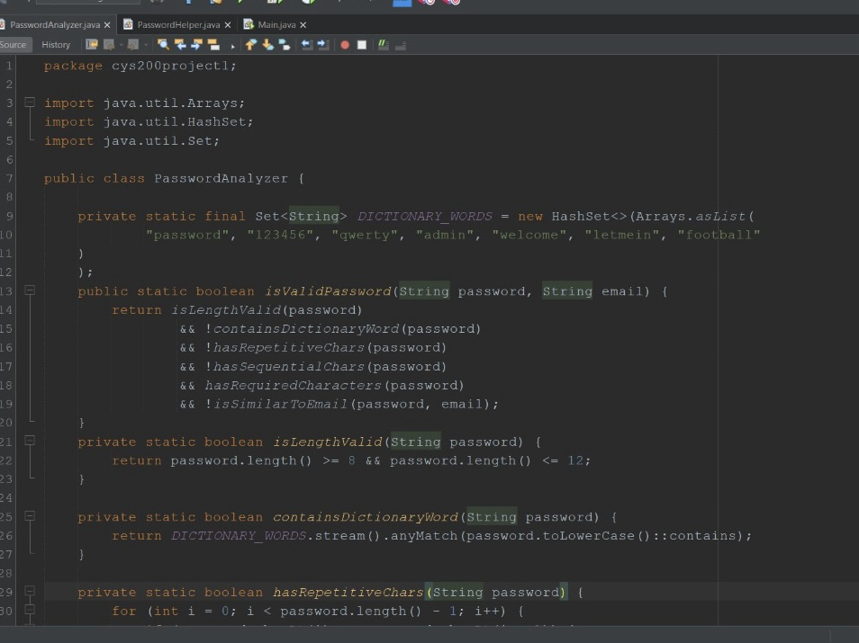
• It provides feedback to the user, suggesting how to improve the password if necessary.
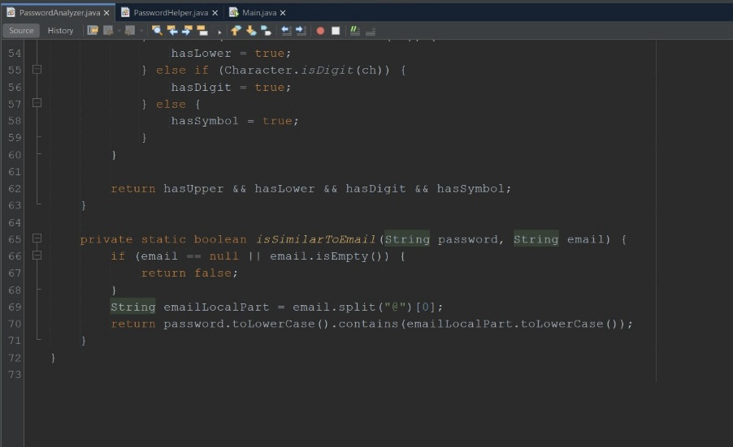
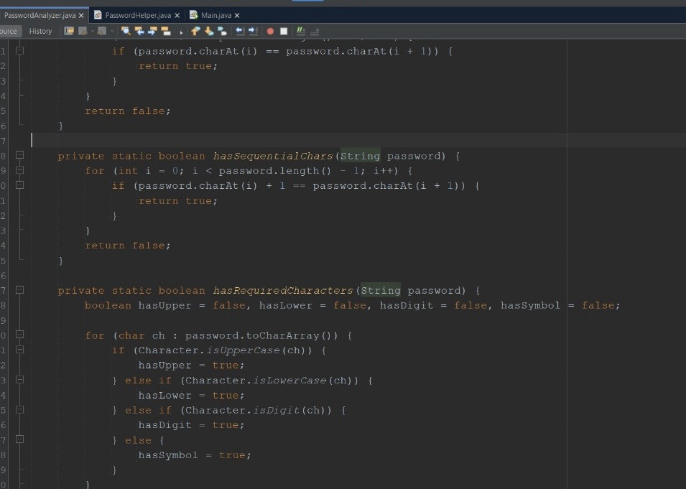

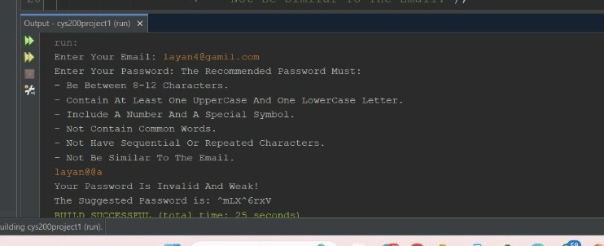
Output:
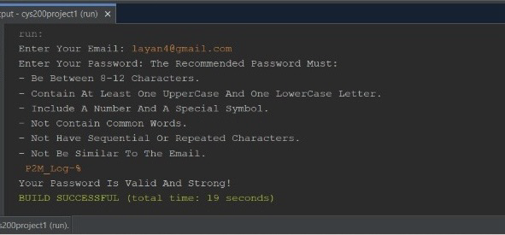

Conclusion
This project provides a valuable tool for users looking to improve their password security. By combining password generation and strength analysis, it helps users create and maintain robust passwords that enhance their digital security. The structured approach in Java ensures scalability and ease of use, making it a practical solution for personal and organizational password management.

